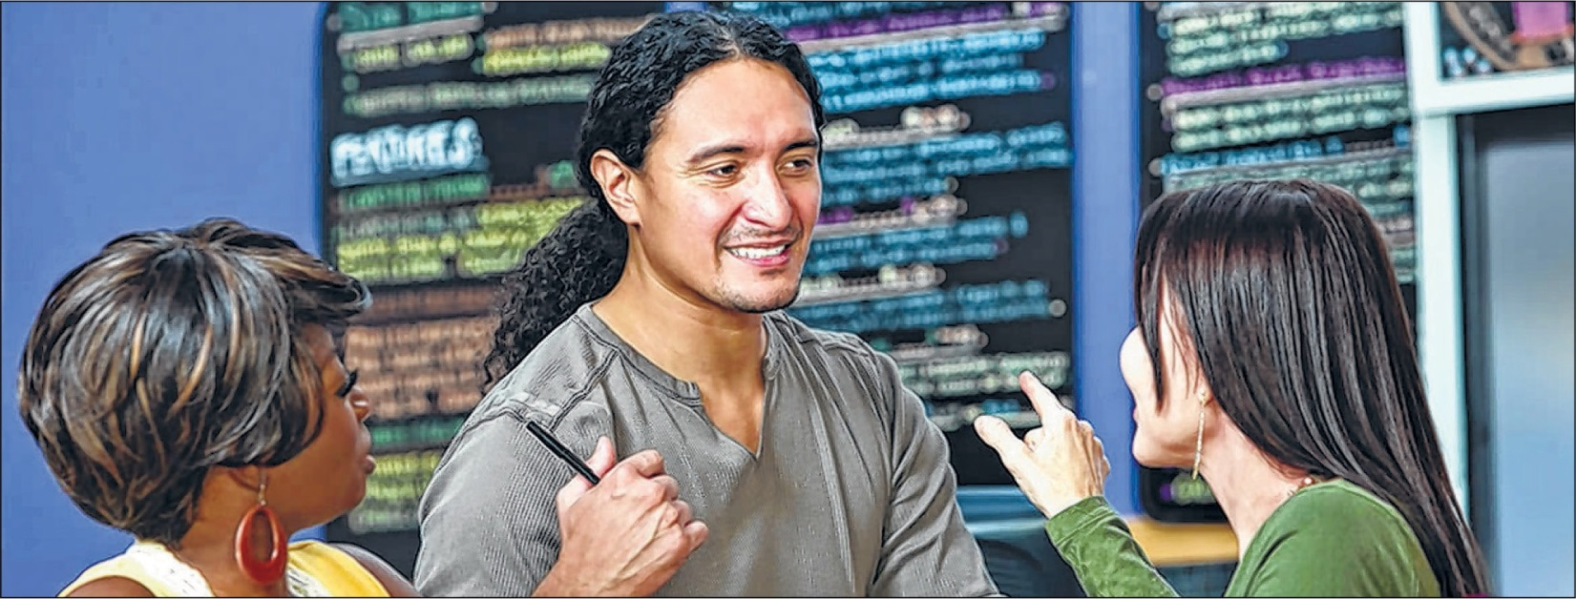
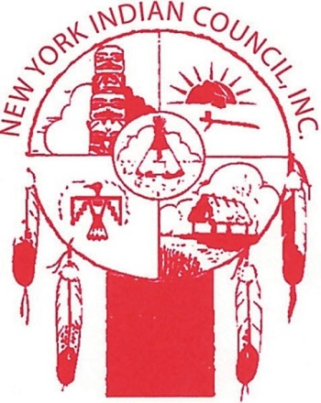
New York Indian Council Workforce Innovation and Opportunity Act
EMPLOYMENT AND TRAINING PROGRAMS FOR NATIVE AMERICANS!!
Are you unemployed and need an employable skill set?

SIGN UP NOW FOR A WIOA OCCUPATIONAL TRAINING PROGRAMS
MONIES AVAILABLE
CDL LICENSE PHLEBOTOMIST EKG TECHNICIAN MEDICAL BILLING & CODING DENTAL ASSISTANT PATIENT CARE TECHNICIAN CERTIFIED NURSE’S ASSISTANT
Other training programs available
Limited College Tuition Funding Available
(Must be enrolled in Federal or State Recognized Native American Tribal Group)

718.215.8417
4332 – 22 nd Street (LIC), Long Island, NY
Monday – Friday, 9AM-5PM WORKFORCE INNOVATION AND OPPORTUNITY ACT

