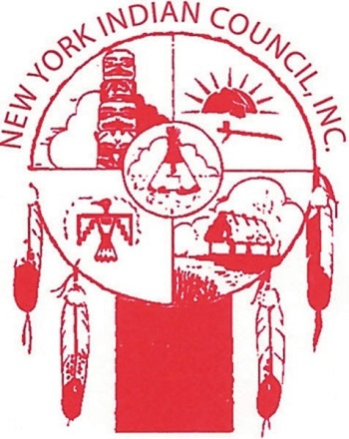
Keith Ross
4332 22nd St
Suite 306
Long Island City,
NY 11101
Tel: 718-215-8417

Subject: New York Indian Council

Dear Gentlefolk:
I am a Woodland Cree from the Lac La Ronge Indian Band and a clergy member from New Brunswick Classis in the Reformed Church in America. I would like to introduce to you a unique nonprofit called New York Indian Council; a subsidiary organization of Rhode Island Indian Council, RI. I am presently working for this nonprofit as an Employment Specialist and we are opening up a new office in Long Island City, Queens.

We at the New York Indian Council are dedicated to helping to improve the quality of life of our Native American community. We offer various services: job search & placement assistance, short term pre-vocational services, individual counseling, career planning, work experience, work reading accreditation, and tuition assistance (limited, and other nonrelated costs).

I am asking for your help, as leaders in your community, to spread the word about the New York Indian Council to Native American people in your congregation, through your newsletters, and on your social media sites use the social media keyword: New York Indian Council. Our target area is the 5 boroughs of New York City. With your help, Native people can start to expand their educational and career horizons. Please review our brochure to advertise as you see fit.

For more information, please call us at (718) 215-8417 or email me at kross@rhodeislandindiancouncil.org.

Best Regards,
Rev. Keith Ross

